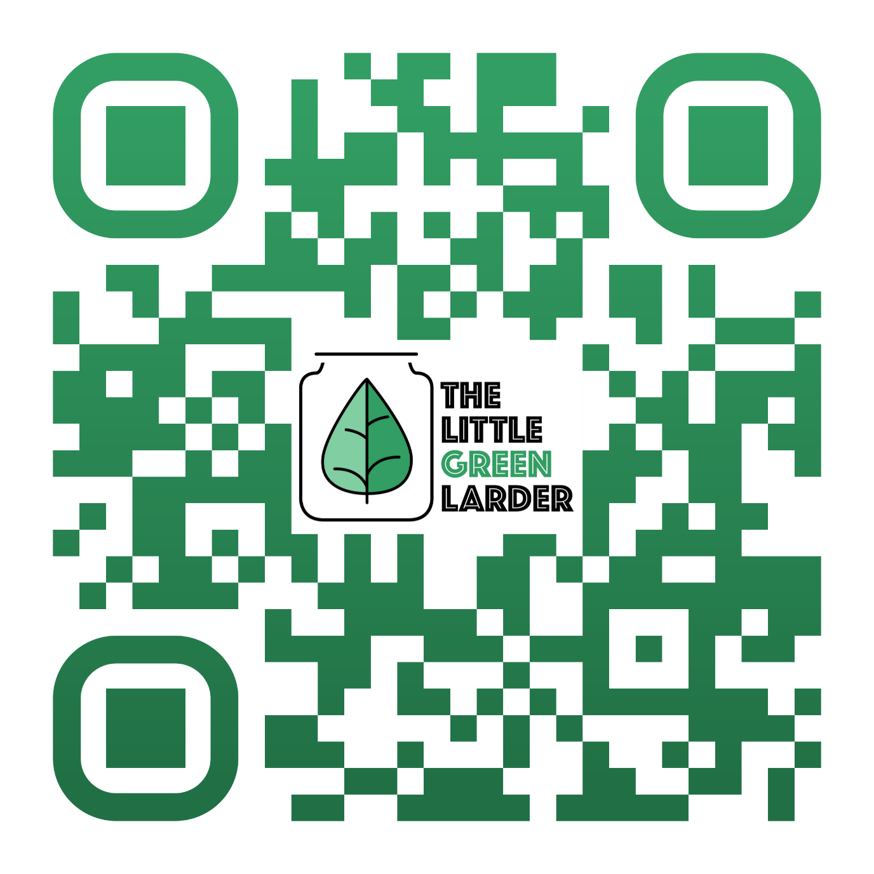p

Check out our new recipe and shopping list app!